Practical 9; Set operation

Step 1: Create two table customer(customer_name,customer_street,customer_city) and borrower(loan_number,customer_name);

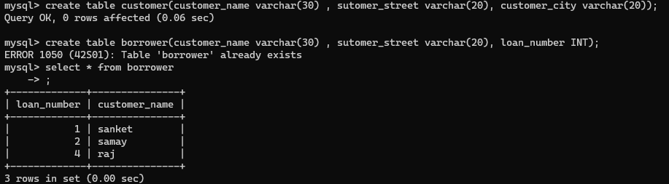

Borrower already exist because of practical 4

Step 2: insert data value in customer table

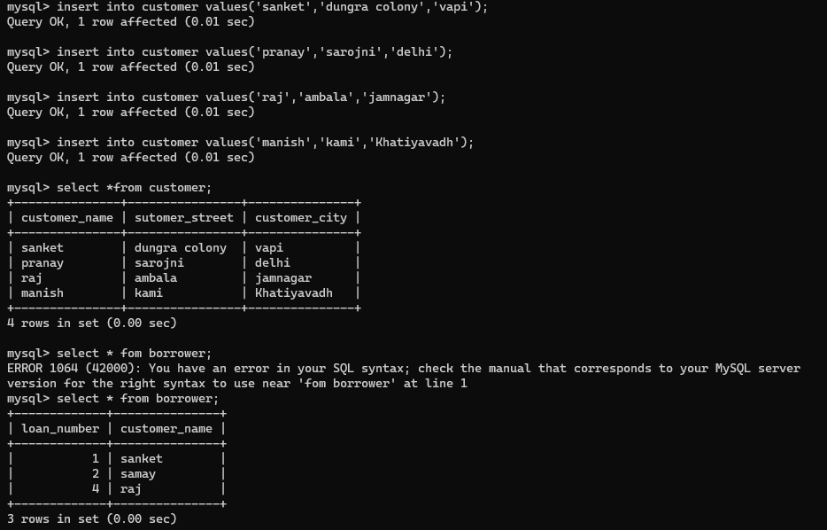

Step 3: perform union, intersect and except over customer_name

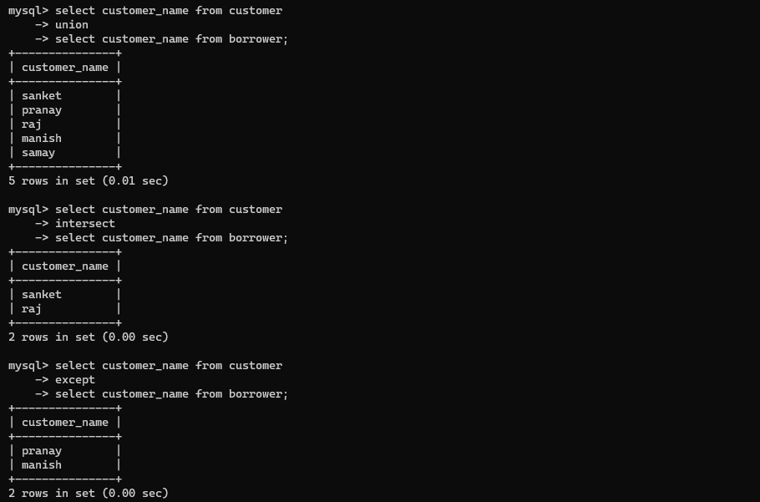

Aggregate function

